Oliver Collins-Cope

2102775@rutc.ac.uk

Learning Aim B & C

Develop a design for an Internet of Things system or device to solve a problem & Carry out the prototyping of an integrated Internet of Things system or device to solve a problem

Unit 19 Internet of Things

Assignment 2

Contents

Introduction 2

Problem definition statement 2

Purpose requirements 3

Diagrammatic illustrations and written annotations 3

Communication infrastructure 3

Feedback 7

Justifying alternative ideas and preferred solution 7

Improvements on design 7

Final design review 7

Creating the system 7

Optimisation 7

Evaluation 7

# Introduction

For this assignment I will be covering the benefits of a healthcare alarm that can aid in detecting when something happens to homeowners, such as someone breaking in. The advantages and disadvantages are vast for this, and some of the advantages include things like early detection for breaches of home, and peace of mind for household/family members themselves. The only disadvantages include the production costs and maintenance cost. This means that once the initial cost is covered and the IoT device is maintained, this device only benefits the homeowners.

# Problem definition statement

The problem in this scenario is the issue of having an alarm that can be used to detect whenever a door or someone has set off a motion alarm that can then alert the homeowner covertly, such as through a mobile notification. The intended audience of this would be the any homeowners looking to secure their property from malicious thieves.

The constraints of this project vary depending on the perspective you take, such as a lack of technical ability not knowing how to utilise these different aspects of the technology, like the motion sensor or camera. Another example of a constraint of this would be the cost to create and make all of these pieces of technology, or to purchase all of these components.

The benefits of using a motion detection system means that it will create a safer environment within the home for the homeowner, and it creates a self-sustaining alarm system that will constantly notify the homeowner if something happens within the home, like unauthorised access.

The nature of user interactivity here will be based in mobile applications and access to alerts/camera through this application. Due to this access, through the mobile application, the user will be able to gain access to their home and view it through the camera, while also being aware of any changes that might happen through the motion detection.

Some accessibility considerations of this application might be audible alerts that describe what can be seen on the camera, such as “a hooded figure moving across the room”, or audio alerts describing the time that the alert was made. Additionally, another accessibility feature that could help might be text-based options for the video feed, i.e., describing what is going on through the use of AI, or a microphone in the camera.

# Purpose requirements

The purpose of the IoT system is to address the alarm system. The system should be able of detecting any movement within a room using a camera connected to a Raspberry Pi or a similar microcomputer. Once movement is detected, the system must send an alert to a mobile device.

Several parts are needed to be able to complete this. Firstly, the system should provide a detection ability. This can be achieved by using cameras capable of differentiating between different types of movement, such as distinguishing a person from a pet, to prevent false alarms.

Next, the system should ensure real-time alert notifications. This means there is a need for consistent connectivity. Continuing, the system should be user-friendly and offer easy customisation of alarm settings, including setting up the app to receive alerts. The system should also provide an interface for system status monitoring and alarm management.

Lastly, the system should be designed considering scalability. As houses expand, the system should allow for an easy integration of additional cameras and motion sensors and be adaptable to new technologies and standards in the IoT ecosystem.

# Diagrammatic illustrations and written annotations

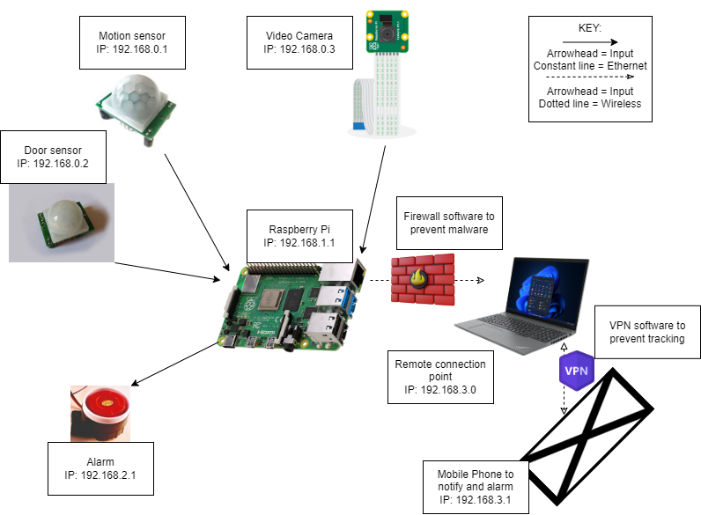

The design of the IoT system involves an optimised functional system. The system's central element is a Raspberry Pi, acting as the microcontroller, interfacing with all components.

The system incorporates a camera, providing the necessary input. Upon sensing motion, these motion detector sends a signal to the Raspberry Pi. The sensor's sensitivity parameters can be changed to prevent false alarms.

The Raspberry Pi, once triggered, sends a notification. This alert is sent to a mobile device through Wi-Fi. Wi-Fi has been selected as the method of sending the notification due to its availability and ease of integration with the Raspberry Pi. It provides the system with internet connectivity, allowing the sending of notifications.

This system design reflects a balance of functionality, and user-friendly operations. The choice of components aligns with the requirement to use off-the-shelf hardware, simplifying the assembly process. The visual diagram accompanying this details the connections and communication flow within this IoT system.

# Communication infrastructure

## Understanding Sensors in the IoT Systems

A key component of an IoT system is its sensors. These devices are tasked with the important role of collecting data from the surrounding environment. These sensors make sure to capture all the data, and in this instance that means video feed and motion detection. Following data collection, raw data is digitised and made understandable. This conversion facilitates real-time data interpretation and interaction by the system, therefore making it efficient.

## Wired and Wireless Communications in IoT

IoT systems heavily rely on both wired and wireless communication channels. Wired connections like Ethernet provide high-speed data capabilities, which are crucial for specific applications within IoT. On the other hand, wireless technologies including Wi-Fi and Bluetooth Low Energy (BLE), introduce flexibility in setup and deployment. In addition, unique identification systems using RFID and QR codes further enhance the performance of IoT applications.

## Actuators in IoT Systems

The actions in an IoT system are primarily driven by actuators, effectively serving as the "muscles" of the system. Based on instructions received from the control system, actuators initiate physical movements or changes by controlling various devices, motors, and servos. This way, the digital data and commands in the system are transformed into concrete actions, sealing the loop within the IoT system.

## Device Domain in IoT Systems

The device domain within an IoT system is what allows communication between its components within a given scope like a Personal Area Network (PAN). Essentially, the device domain is responsible for creating an interconnection between multiple devices, such as sensors and actuators, enabling data sharing environment.

## Network Domain in IoT

Linking Machine-to-Machine (M2M) gateways with M2M applications is the primary role of the network domain within an IoT system. It uses Wide Area Networks (WAN) or Wireless Local Area Networks (WLAN) to ensure connectivity and data sharing between system components, no matter their geographic locations.

## Application Domain in IoT Systems

The application domain forms the intermediary layer within an IoT system. This is where data captured by sensors gets processed and is made available to business logic layers. The application domain is tasked with making sense of the data and providing actionable insights that deliver value to the end-user or customer. The application domain, in essence, turns raw data into comprehensible and useful information for informed decision-making and automatic responses.

# Feedback

# Justifying alternative ideas and preferred solution

# Improvements on design

# Final design review

# Creating the system

# Optimisation

# Evaluation